Page Name: Social Inclusion and Community Activation Programme

Please place the below text above case study videos
The Social Inclusion and Community Activation Programme (SICAP) 2024-2028 provides funding to tackle poverty and social exclusion at a local level through local engagement and partnerships between disadvantaged individuals, community organisations and public sector agencies.
Administered by Pobal, SICAP 2024-2028 is co-funded by the Irish Government, through the Department of Rural and Community Development, and the European Social Fund Plus under the Employment, Inclusion, Skills, and Training (EIST) Programme 2021-2027.
The SICAP contract for Offaly is managed by the Offaly Local Community Development Committee and is implemented by Offaly Local Development Company.
SICAP is a targeted, holistic programme, for those who are most disadvantaged and less likely to access mainstream services. The programme provides supports directly to communities and links them into existing services.
The programme works with specific target groups, under two goals. Goal One aims to contribute to building more sustainable, inclusive and empowered communities, while Goal Two seeks to empower disadvantaged people to improve the quality of their lives.
Below, you can view some recent case studies, given an idea of the work done through the programme.

Case study video links
2020: https://youtu.be/1fu60xmusCI
2021: https://youtu.be/5CKkxHOKvJ0
2022: https://youtu.be/ISKtrWlIxgA
2023: https://www.youtube.com/watch?v=Bo9qEg9Di-w&feature=youtu.be

For more information on the programme, contact:
Louise Larkin,
Offaly Local Development Company,
Millennium House,
Main Street,
Tullamore,
Co. Offaly.

Tel: 087 6925276
Email: llarkin@offalyldc.ie

Logo strapline for page

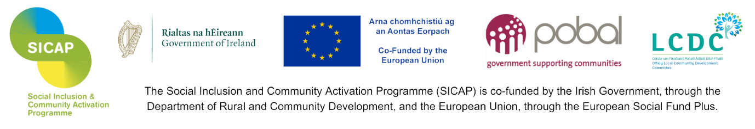

Photos for page

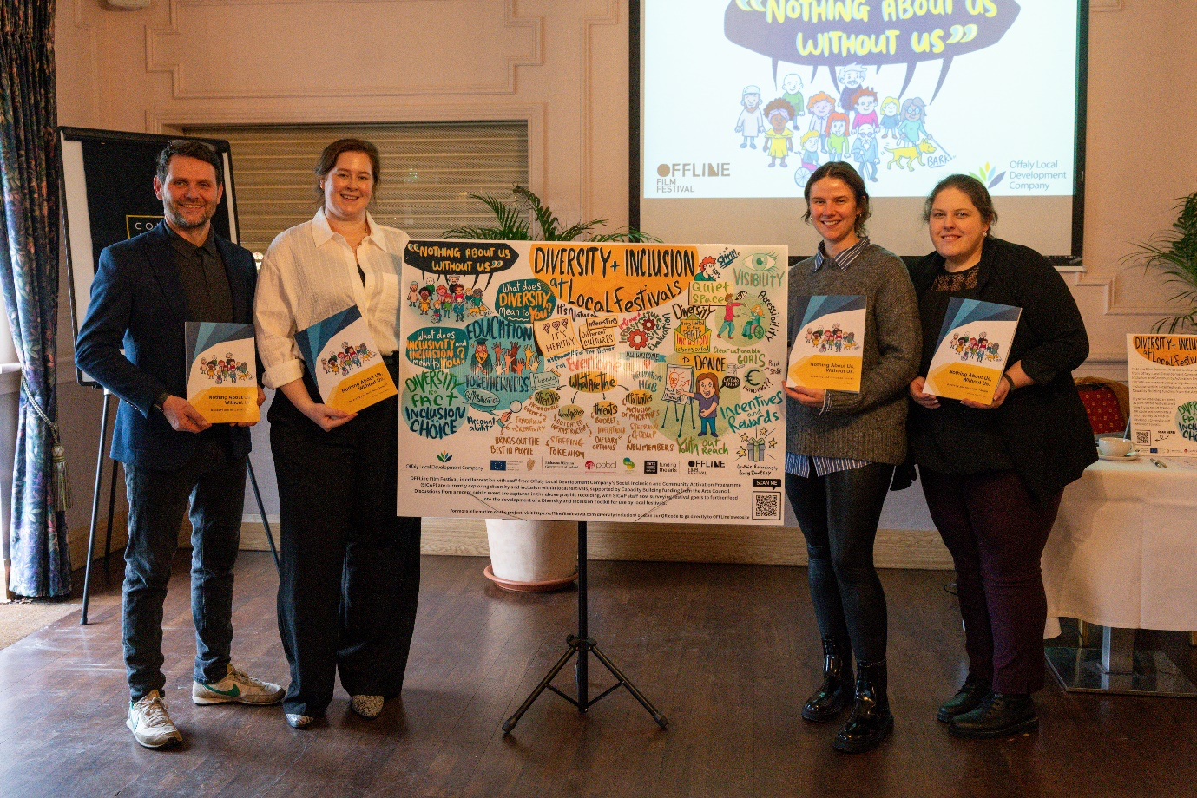
Nothing About Us Without Us, Diversity and Inclusion Toolkit Launch, February 2024

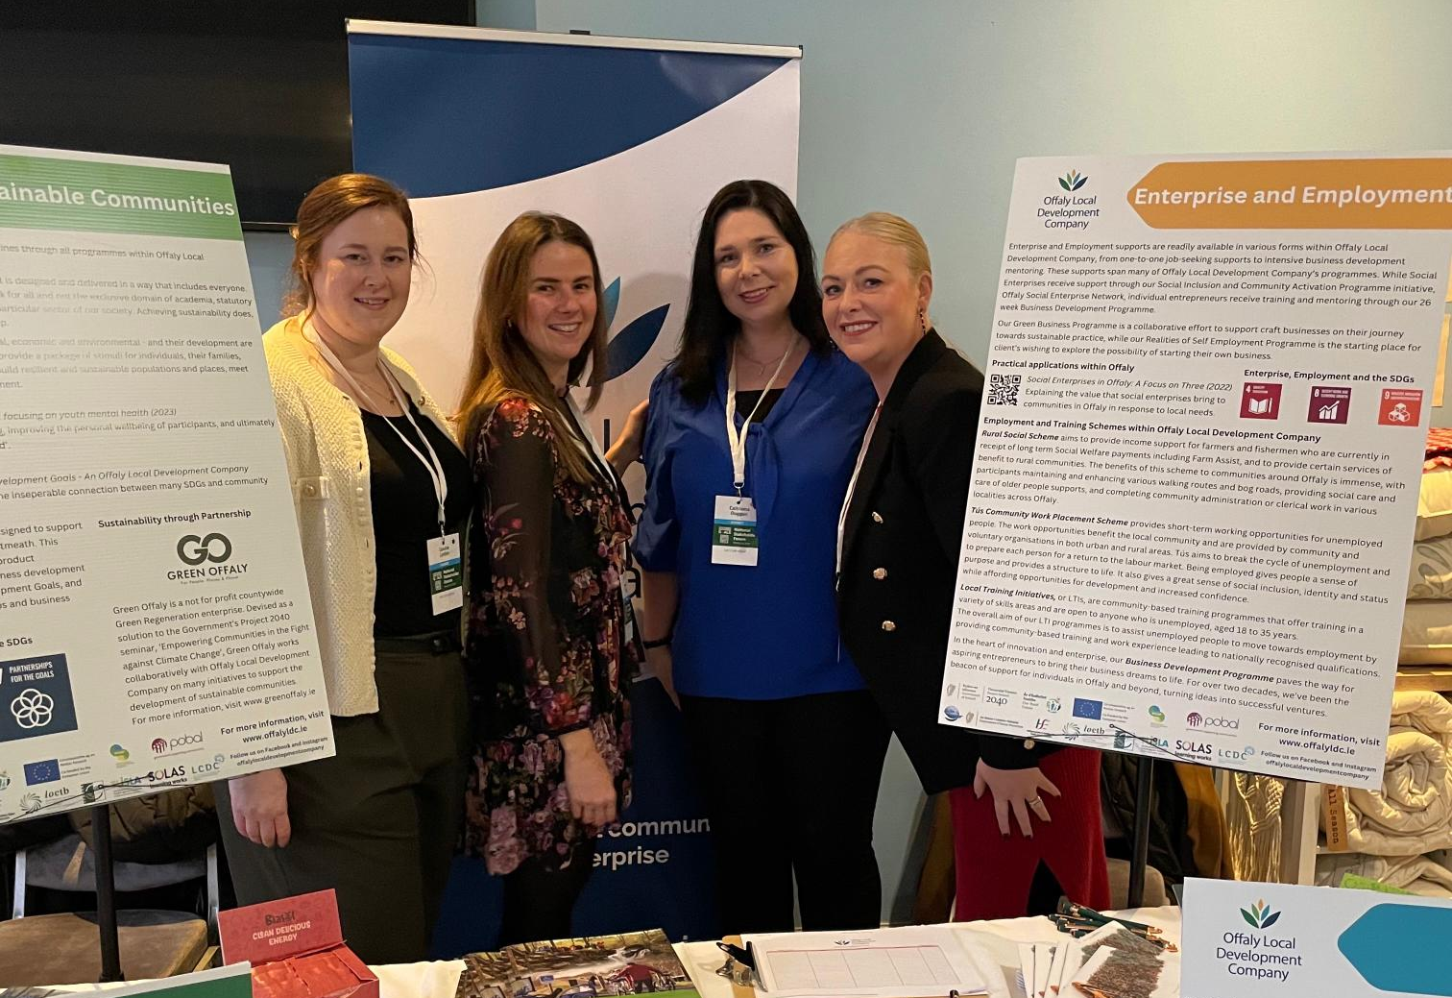
SDG National Stakeholder Forum in Tullamore, March 2024

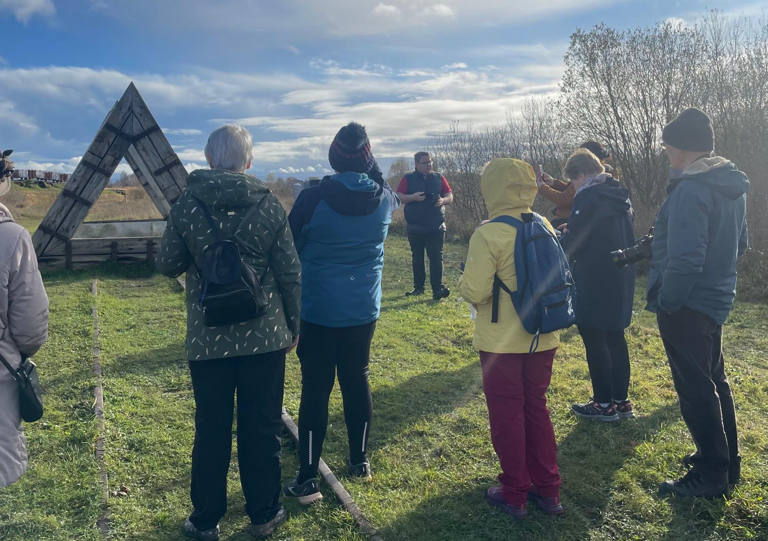
Capturing Offaly photography walk with Tom O’Hanlon, November 2023

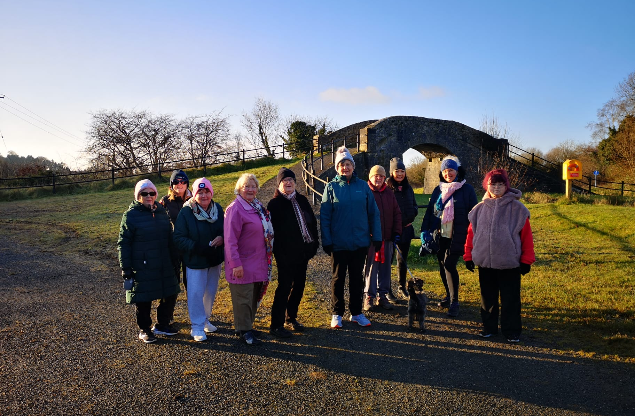
Edenderry Walking Group, December 2023

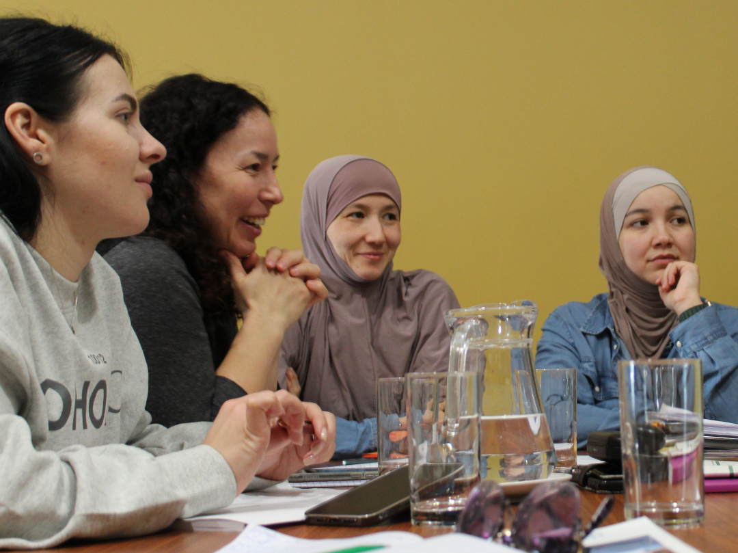
Conversational English classes, March 2023

